**Bolt Torquing Services**

Mechanical Jointing and structural connection of pressurized equipment in Oil & Gas, Petro-Chemical & Power Generation industries are made via. Bolted flanges for easy installation and removal for re-work and replacement.

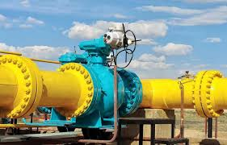 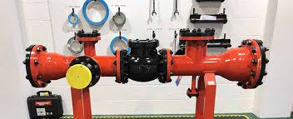

In order to avoid leakage of costly/toxic fluids from these joints, qualified and trained manpower equipped with proper tools is required for alignment, packing and bolting/torquing of flanged connections.

Accurately and evenly torqued bolts will not only provide required tension but also ensure, uniform gasket compression, even spacing between flange faces, proper flange alignments and evenly distributed tensile load on all bolts.

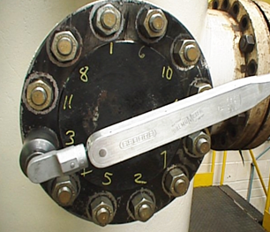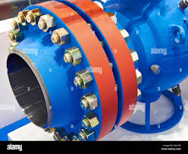 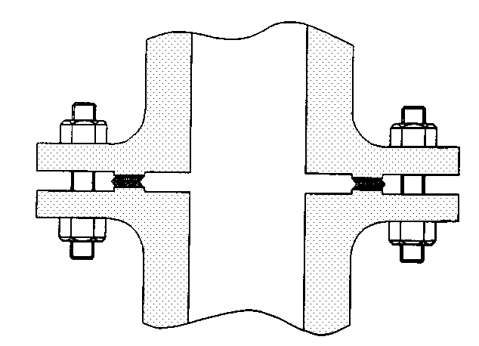

Whereas, incorrectly and unevenly torqued bolts will lead to Uneven Gasket Compression, Scattered bolt load, reduced bolt/flange Yield resulting into overstressed joints prone to leakage under fluid pressures.

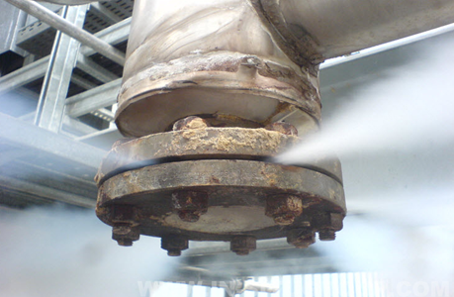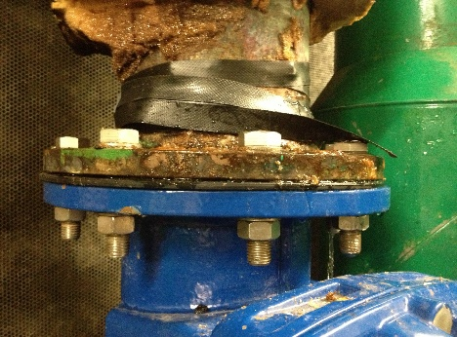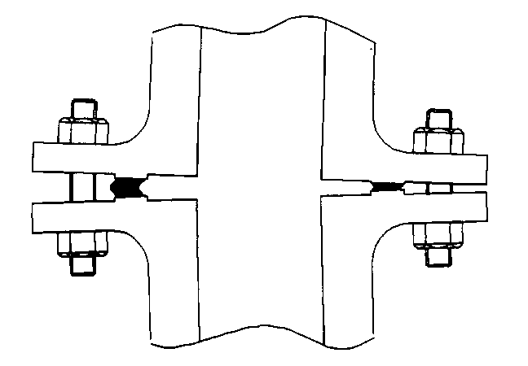

Al Meezan Industrial Metrology Services is pleased to provide bolt torquing services with qualified and trained manpower and right size/type calibrated hydraulic and hand torque tools. AIMS Services will help the client to make the right joints in first attempt in order to;

* Prevents leaks and disasters.
* Reduce rework cost and time.
* Reduce emission and pollution.
* Ensure safety and enhance credibility.

